**Guide Book Pro**

**I5:**

**Version 6.0**

**Team Savants: Alex Rodriguez, Ty Mcphail, Adam Axelrod, Arturo Garcia, Brody Hayden**

# Table of Contents

Table of Contents 1

1. Class Diagram 2

2. Database design 3

3. User Interface Navigation Diagram and Screen Layouts 5

4. Gantt Chart 6

5. Use Interface Prototype 7

# **Class Diagram**

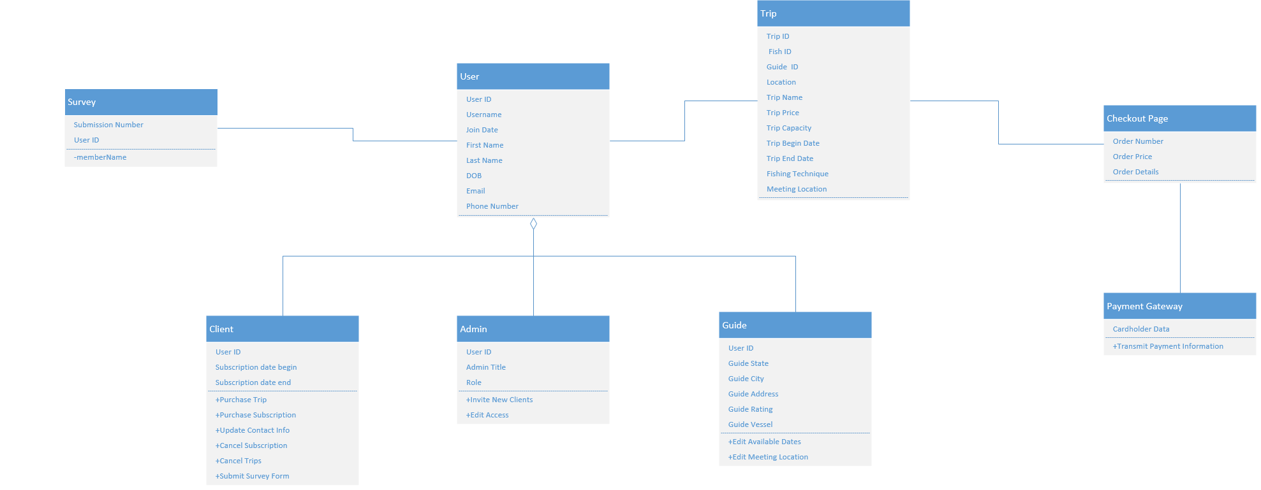

**1.1 Class Diagram Narrative**

During this class diagram's development, use cases and prototype analysis were utilized to understand and convey the interaction of objects in this system. Above we have displayed each of them including each type of user, trip page, checkout page, payment gateway, and the survey form. There are certain attributes that we are interested in seeing for each type of user, like first name and last name, while types of users have more specific information like meeting location, subscription status, or administrator role. As some types of users have different types of data that is specific to them, they also have specific actions that they can perform. Administrators of this system can edit access to user accounts, guides can adjust their availability, users can purchase a subscription, and these are all examples of how each class is different despite all being users of the system. Other key classes represent objects like survey forms and the payment gateway, Stripe, which are critical to stakeholders of this system. The survey form is available to clients and allows the system owners to capture information which will help gauge interest in trips for accurate inventory control. The payment gateway is embedded in the checkout page and captures payment information for secure transmission and further payment processing, which is the final process before an order is confirmed.

# **Database design**

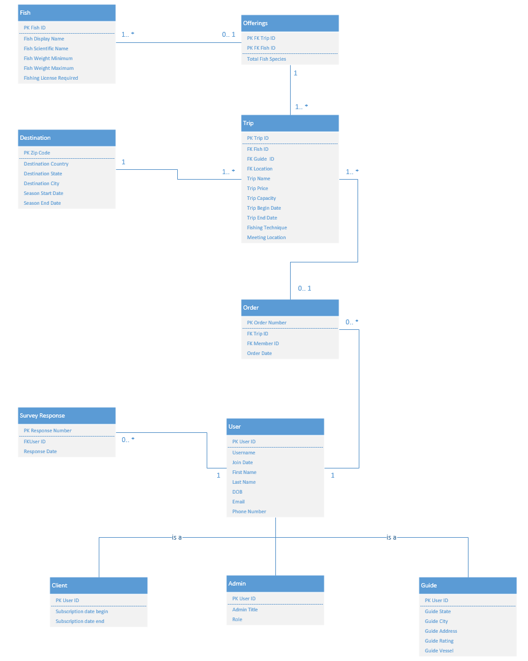

**2.1 Database Diagram Narrative**

The design of this database diagram focused primarily on the key classes that were present in the class diagram, but additions were required to normalize to the third normal form. Bridge entities like “Offerings” and “Orders” had to be introduced to resolve many to many relationships and careful selection of attributes was required to avoid partial dependencies. Attributes were selected in a way to ensure fields would remain as single points of data and avoid unstructured or multivalued entries. As seen in the class diagram, we left the subtype of users broken into their own classes and the omission of the payment gateway class was made. This was intentional because there will not be any payment information stored as this system should remain out of scope of PCI regulations.

**2.2 Data definitions**

|  |  |  |  |  |
| --- | --- | --- | --- | --- |
| **USER** |  |  |  |  |
| Attribute | Definition | Type | Size | Key |
| User ID | Unique identifier for the user | Int | 4 Bytes | Primary Key |
| Username | Username for login | String | 255 Bytes (Max) | N/a |
| Email | User's email address | String | 255 Bytes (Max) | N/a |
| First Name | User's first name | String | 255 Bytes (Max) | N/a |
| Last Name | User's last name | String | 255 Bytes (Max) | N/a |
| DOB | User's date of birth | Date | 3 bytes | N/a |
| Join Date | Date the User Joined | Date | 3 bytes | N/a |
| Phone Number | User's phone number | String | 10 characters | N/a |
| **ADMIN** |  |  |  |  |
| Attribute | Definition | Type | Size | Key |
| User ID | Unique identifier for the admin | Int | 4 Bytes | Primary Key |
| Admin Title | Internal title held | String | 255 Bytes (Max) | N/a |
| Role | Role given to the administrator | String | 255 Bytes (Max) | N/a |
| **GUIDE** |  |  |  |  |
| Attribute | Definition | Type | Size | Key |
| User ID | Unique identifier for the fishing guide | Int | 4 Bytes | Primary Key |
| Guide State | State the guide is in | String | 255 Bytes (Max) | N/a |
| Guide City | City the guide is in | String | 255 Bytes (Max) | N/a |
| Guide Address | Guide's specific address | String | 255 Bytes (Max) | N/a |
| Guide Rating | The guide's overall rating | Decimal | 17 Bytes (Max) | N/a |
| Guide Vessel | Vessel the guide uses | String | 255 Bytes (Max) | N/a |
| **CLIENTS** |  |  |  |  |
| Attribute | Definition | Type | Size | Key |
| User ID | Unique identifier for the fishing guide | String | 4 Bytes | Primary Key |
| Subscription Beginning Date | Time the subscription began | Date | 3 bytes | N/a |
| Subscription End Date | Time the subscription will end | Date | 3 bytes | N/a |
| **TRIP** |  |  |  |  |
| Attribute | Definition | Type | Size | Key |
| TripID | Unique identifier for the fishing trip | Int | 4 Bytes | Primary Key |
| Title | Title of the fishing trip | String | 255 Bytes (Max) | N/a |
| Location | Location of the fishing trip | String | 255 Bytes (Max) | N/a |
| Date | Date of the fishing trip | Date | 3 bytes | N/a |
| Price | Price per day | Decimal | 17 Bytes (Max) | N/a |
| Guide Name | Name of the fishing guide | String | 255 Bytes (Max) | N/a |
| Target Species | List of fish species targeted on the trip | List | 255 Bytes (Max) | N/a |
|  |  |  |  |  |
| **FISH** |  |  |  |  |
| Attribute | Definition | Type | Size | Key |
| Fish ID | Unique identifier for the fish | Int | 4 Bytes | Primary Key |
| Fish Dsiplay Name | Display name of the fish | String | 255 Bytes (Max) | N/a |
| Fish Scientific name | Scientific name of the fish | String | 255 Bytes (Max) | N/a |
| Fish weight minimum | Minimum weight of the fish | Decimal | 17 Bytes (Max) | N/a |
| Fish weight Maximum | Maximum weight of the fish | Decimal | 17 Bytes (Max) | N/a |
| Fishing License Required | Is a fishing license require for the fish | Boolean | 255 Bytes (Max) | N/a |
| **DESTINATION** |  |  |  |  |
| Attribute | Definition | Type | Size | Key |
| Zip Code | Zip code of the destination | Char | 10 characters | Primary Key |
| Destination Country | Country of the destination | String | 255 Bytes (Max) | N/a |
| Destination State | State of the destination | String | 255 Bytes (Max) | N/a |
| Destination City | City of the destination | String | 255 Bytes (Max) | N/a |
| Season Start Date | Beginning of the season | Date | 3 bytes | N/a |
| Season End Date | End of the season | Date | 3 bytes | N/a |
| **ORDER** |  |  |  |  |
| Attribute | Definition | Type | Size | Key |
| Order Number | Unique identifier for each order | Int | 4 Bytes | Primary Key |
| Order Date | Time of the completed order | Date | 3 bytes | N/a |
| Trip ID | ID of the trip/s that the order is associated with the order | Int | 4 Bytes | Foreign Key |
| Member ID | ID of the client that submitted the order | Int | 4 Bytes | Foreign Key |
| Order Date | Date the order was submitted | Date | 3 bytes | N/a |
|  |  |  |  |  |
| **SURVEY RESPONSE** |  |  |  |  |
| Attribute | Definition | Type | Size | Key |
| Response Number | Unique identifier for each response | Int | 4 Bytes | Primary Key |
| Response Date | Time response was completed | Date | 3 bytes |  |
| UserID | User associated with form submission | Int | 4 Bytes | Foreign Key |
| **OFFERINGS** |  |  |  |  |
| Attribute | Definition | Type | Size | Key |
| Trip ID | Trip associated with offering list | Int | 4 Bytes | PK and FK |
| Fish ID | Fish associated with offering list | Int | 4 Bytes | PK and FK |
| Total Fish Species | Total offered based on combination of trip and fish | Int | 4 Bytes | N/a |

# User Interface Navigation Diagram and Screen Layouts

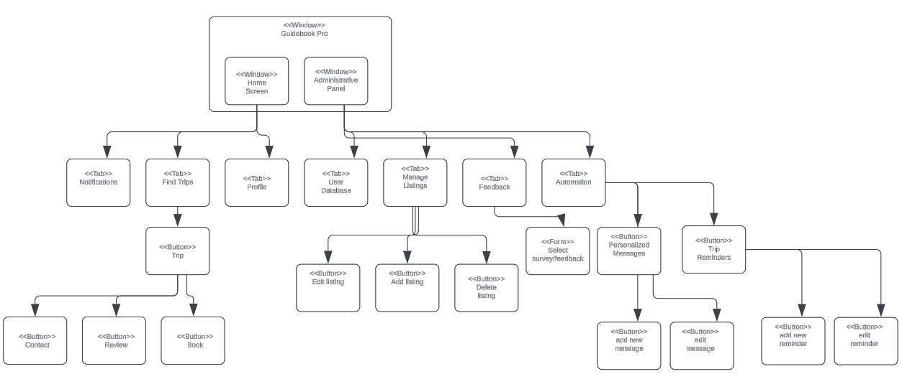

# Gantt Chart

[Link to Gantt Chart](https://cardmaillouisville.sharepoint.com/:x:/r/sites/Savants/_layouts/15/Doc2.aspx?action=edit&sourcedoc=%7B4cd96644-11c8-478a-8eb5-6ea2956c4bb1%7D&wdOrigin=TEAMS-MAGLEV.teamsSdk_ns.rwc&wdExp=TEAMS-TREATMENT&wdhostclicktime=1713289470180&web=1)

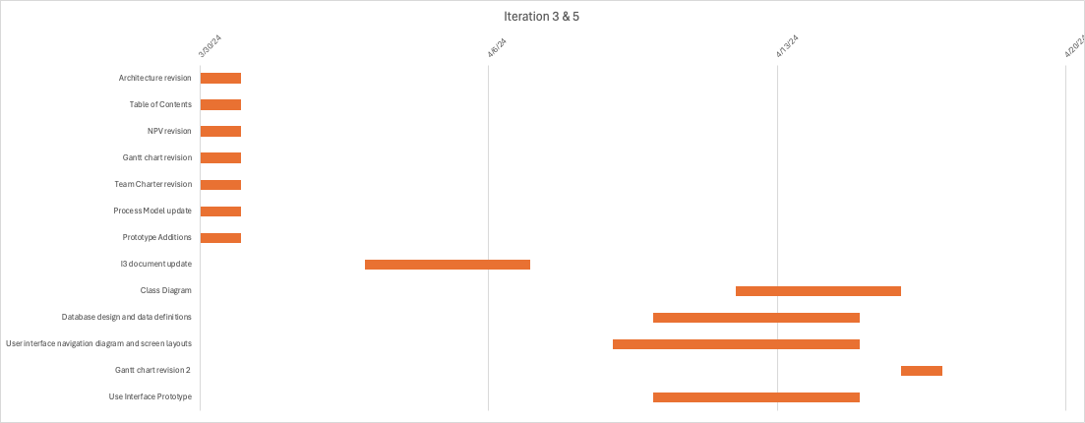

# Use Interface Prototype

